**MIS 110**

**INDIVIDUAL PROJECT – PYTHON PERSONAL PROJECT**

**FALL 2022 SEMESTER**

**Prof. Kevin Ryan**

*FORMULA 1 AND THE STOCK MARKET*

*FERRARI’S RACING SUCCESS AND THE STOCK MARKET*

**Goal:** Work individually to develop an interesting and worthwhile program and write a report

explaining how it works and what it does.

**Project Due Date:** Wednesday, December 14th by 11:59 PM

**Grading:** 20% of your final grade

**Project Requirements**

The MIS 110 project is an individual project where you take the concepts we learned in the class and apply them to a new program. Your project should include the topics we discussed in the lectures and recitations. For example:

* Variables
* Lists
* Functions
* Importing data
* Classes
* Additional items

**Project Features**

We encourage that the program you develop should be answering a question (example below). Although graphing datasets would be adequate as well. Here are some examples of what you can do:

* What has the rate of change in COVID-19 cases been in the US compared to other developed countries?
* Which stocks in a sector have been the best performers during this pandemic?
* What are the busiest buildings at Stevens during the week?

One example; using Yahoo Finance to get historical stock data. If you do a Google search on a stock (or stocks) you are interested in, you can specify the date range and download the data in the “Historical Data” tab.

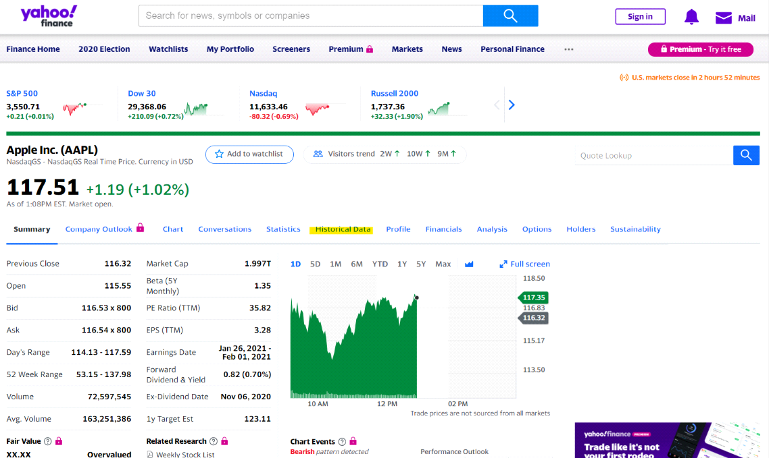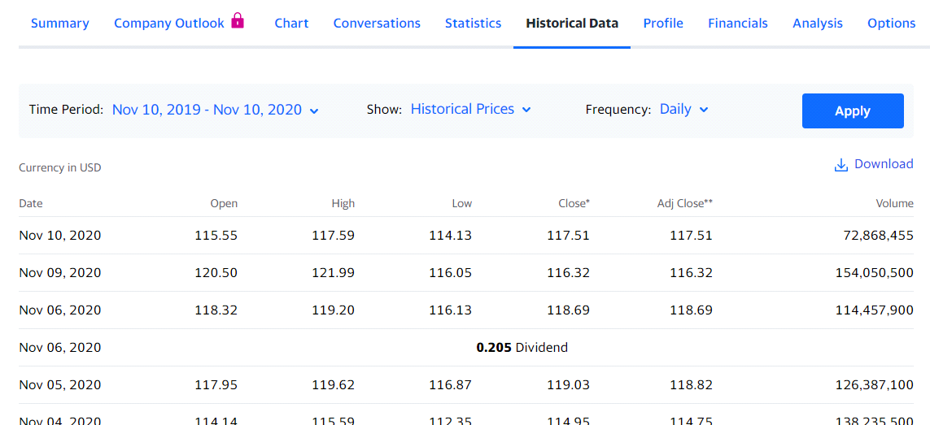

There are many databases related to things like COVID-19 cases, hurricane paths, Stevens’ course data, or location energy usage that you can download as files or access through APIs where you can request data. If you have trouble finding/accessing the data you would like to use, please feel free to let us know and we will try to help you with that. Also, think about the way you are getting the data. If you want historical stock prices on 100 stocks, instead of doing that manually you can create a script that does that for you. The TAs will also be here to help you manage your code by giving you tips on using multiple scripts for a project, better function structure, and other items.

**Report**

There is a report aspect to the individual project. The report should be at a minimum of 2 pages (with pictures of your source code and its outputs). You should explain the main parts of what your program does (ie: collecting data, analyzing data, class structures, etc.). This will be submitted on Wednesday, December 14th by 11:59 PM.

**Project Demonstration**

Everyone will have a scheduled project demonstration after Wednesday, December 14th with one of the TAs. This time should be used to briefly go over the structure of your program and its outputs, similar to what you would have done in your report.